Cover | Title | Description of Resource
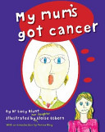 | My Mum’s Got Cancer  Author  Lucy Blunt - 2009 | It talks directly to the child using open and charming illustrations which take away the fear and secrecy of cancer treatment. This is the first book of its kind in Australia.  Review from  books.google.com
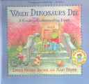 | When Dinosaurs Die:  A Guide to Understanding Death  Author  L Kransky Brown & M Brown 1998 | Explains in simple language the feelings people may have regarding the death of a loved one and the ways to honor the memory of someone who has died.
No Image | A New Sister for Julian  Author:  Anne-Marie Chapouton  1985 | In story format childbirth and pregnancy are explained.
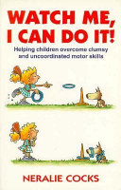 | Watch Me, I can Do It.  Author: Neralie Cocks  1996 | Book sets out to provide parents and carers with strategies which may help children overcome clumsiness and uncoordinated motor skills

Cover | Title / Publisher | Description of Resource
No Image | Books that help Children  Author: J Fox  1995 | An annotated bibliography of mostly Australian children's stories to help 6-12 year-olds deal with issues like change, sibling rivalry, illness, disability, grief, child abuse, etc.
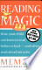 | Reading Magic  Author: Mem Fox  2001 | Startegies on how your child can learn to read before school and other read aloud miracles.
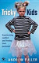 | Tricky Kids  Author: A Fuller  2007 | What would it be like to have to parent Bart Simpson or Angelica Pickles? Every day, many parents and teachers struggle with challenging (and lovable) children who have wilful personalities. These are often kids who are stubborn, defiant, determined, free-spirited or just plain difficult. Yet while they may be hard work, they are often the movers and shakers of the future. Many of history’s great achievers, political leaders and national figures were forceful children.  From: books.google.com.au
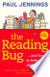 | The Reading Bug  Author: P Jenning  2008 | This new edition of the bestselling guide contains a supplementary chapter, plus fully updated booklists.
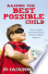 | Raising the Best Possible Child  Author: J Jackson King | In Raising the Best Possible Child you will learn how to: Ignore parenting myths and be guided by the most up-to-date information on all aspects of child-rearing, including childcare, breastfeeding, leaving to cry, sleep, nutrition.  Review from.  books.google.com
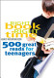 | Right Book Right Time  Author:  Agnes Niewenhuizen  2008 | 500 Great Reads for Teenagers
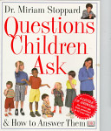 | Questions children ask and how to answer them  Author:  M Stoppard 1997 | Provides answers for children's questions such as "Where do babies come from?," "What's a divorce?," and "Why can't I talk to strangers?"
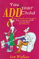 | You & Your ADD child  Author: I Wallace  1996 | Introduces parents to a variety of practical strategies, designed specifically for ADD, that can help them and their children manage problems. Tackles problems with low self-esteem, poor social skills, defiance, school issues, aggression and sibling rivalry.
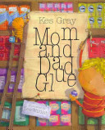 | Mum & Dad Glue  Author: L Wildish  2009 | His parents have come undone and he wants to mend their marriage, stick their smiles back on and make them better. This story is brilliantly told with a powerful message that even though his parents may be broken, their love for him is not.
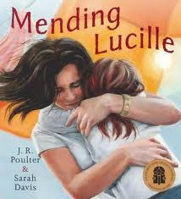 | Mending Lucile  Author: J R Poulter  2008 | Mending Lucille charts the process of grief and healing through the young girl s attachment to a broken doll, Lucille. One day, she and her father meet Chrissie, a kind waitress who mends the doll.
 | Before The School Bell  Author: Wendy Barrett 2006 | A Story about Organisation
 | The Goal Keeper  Author: Wendy Barrett 2006 | A Story About Resilience
 |  | .
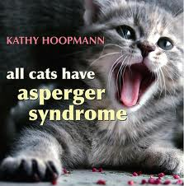 | All Cats Have Asperger Syndrome  Author: K Hoopman 2007 | Jessica Kingsley Publishers, 30/11/2006 - 65 pages  All Cats Have Asperger Syndrome takes a playful look at Asperger Syndrome (AS), drawing inspiration from the feline world in a way that will strike a chord with all those who are familiar with AS. Delightful colour photographs of cats bring to life familiar characteristics such as sensitive hearing, scampering at the first sign of being stroked, and particular eating habits. Touching, humorous and insightful, this book evokes the difficulties and joys of raising a child who is different and leaves the reader with a sense of the dignity, individuality, and potential of people with AS.
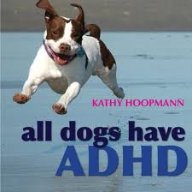 | All Dogs have ADHD  Author: K Hoopman 2009 | All Dogs Have ADHD takes an inspiring and affectionate look at Attention Deficit Hyperactivity Disorder (ADHD).
No Image | Building Foundations: Autism: Your Child, Your Family  Autism Spectrum Australia  2008 | DVD
Most descriptions obtained from publishers or Googlebooks.com

